Myo Simulator
Summary
The Myo Simulator is system created to simulate outputs of a Myo arm band, it is designed alongside project Midas to send over simulated Myo data. Its functionalities include creating/loading a script in human readable format and recording actual Myo data and store it in binary file format.
Architecture
Figure 1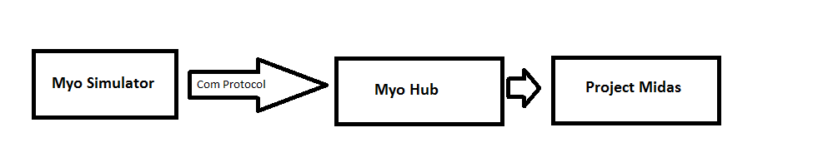
The Myo simulator communicates with project Midas through the communication protocol which sends over simulated myo data. Myo simulator is designed to work with two different data type, human readable format and binary format. The communication protocol breaks down the human readable format into binary format then sends the data over to project Midas.
Functions
Scripts: User is able to create scripts for Project Midas in the simulator by entering desired values into the text fields provided and click on add button. When script is ready, user click on the send data button to send the script over to Project Midas. Users will also be able to save the script they created and reload saved scripted by using the save script and load script buttons.

Simulator Data Types
Two data types were designed for the myo arm band simulator, human readable format and binary format, to mimic the data output of the myo arm band. At run time the human readable format is parsed into the binary format before being sent over to the myo hub.
Human readable format:
Every line in the human readable format is a command (pose/orientation) for the myo, it takes the following forms:
move([5,5], [10,15], 50)
async(3, 20)
move([10,15], [1,1], 100)
async(fist, 25)
expect(vibrate, 50)
delay(50)
The first word in a line signifies what type of command it is follow by details of the command and the time stamp, there are four types of commands:
Orientation/movement (move) – (orientation data. orientation data, timestamp)
Poses/myo events (async), - (event type, timestamp)
Feedback events to the armband (expect), (event type, timestamp)
Delay – (length (ms))
Binary Format:
Binary format is made up of 44 bytes, each of the following boxes represent a 4 byte float data:
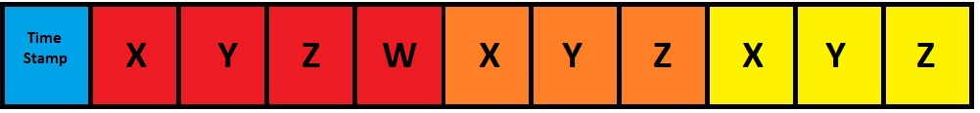
|------------Quaternion data------------|-----accelerometer data------|--------gyroscope data--------|
The very first bit of the binary data format is used to presentation the data type.
0 – Orientation, 1 – Async event

